WEEK 5

QN 1:

Write a program that prints a simple chessboard.

Input format:

The first line contains the number of inputs T.

The lines after that contain a different values for size of the chessboard

Output format:

Print a chessboard of dimensions size \* size. Print a Print W for white spaces and B for black spaces.

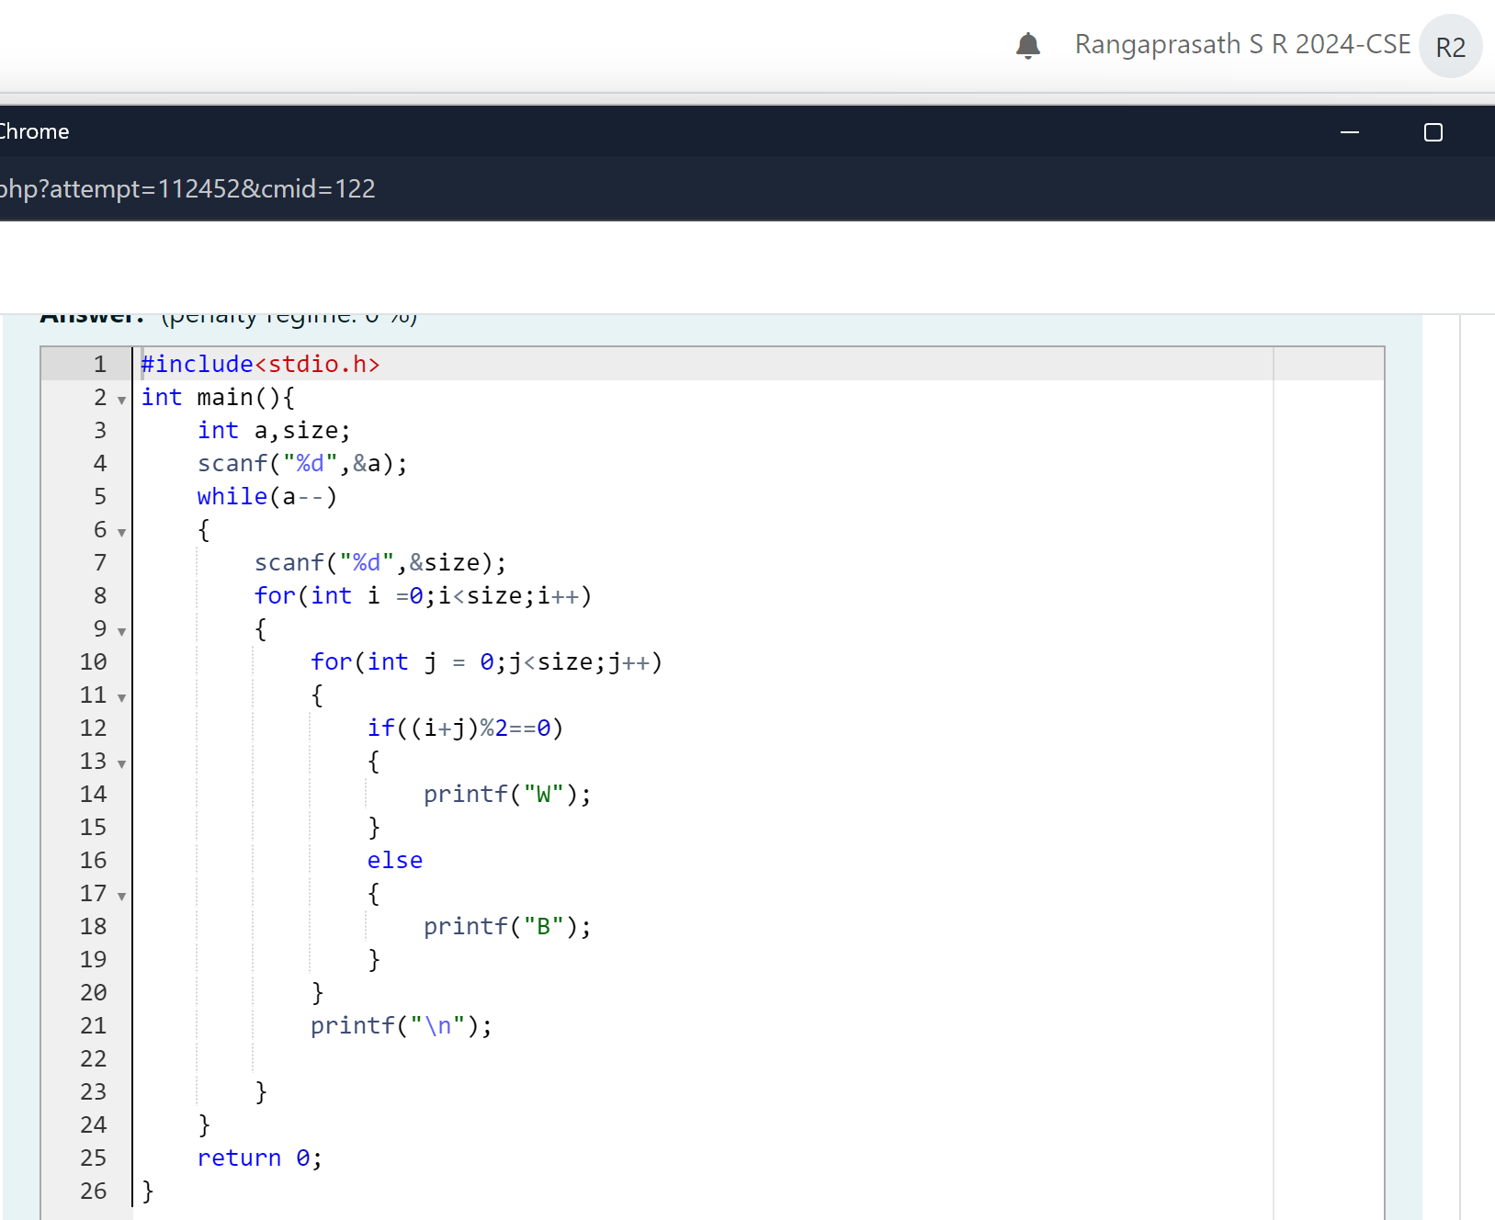

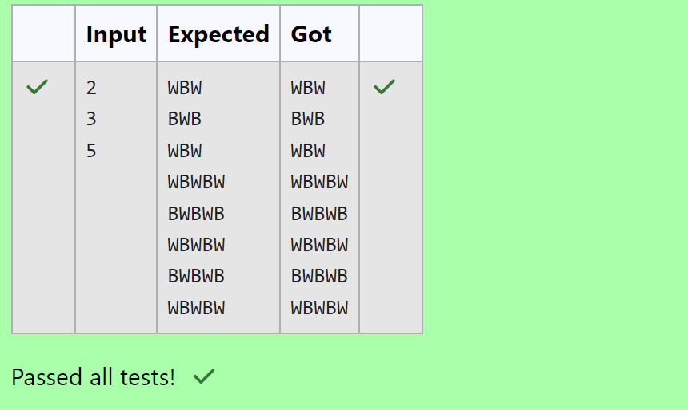

QN 2:

Let's print a chessboard!

Write a program that takes input:

The first line contains T, the number of test cases

Each test case contains an integer N and also the starting character of the chessboard

Output Format

Print the chessboard as per the given examples

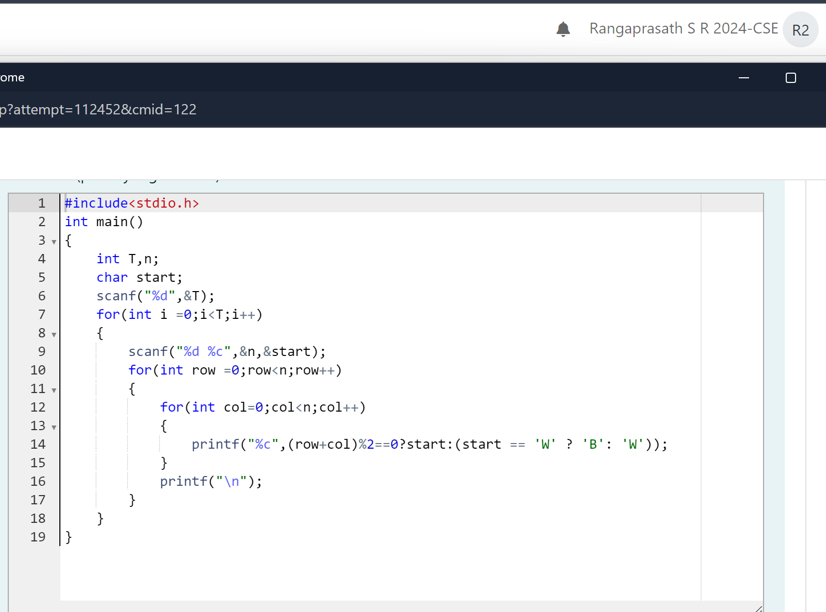

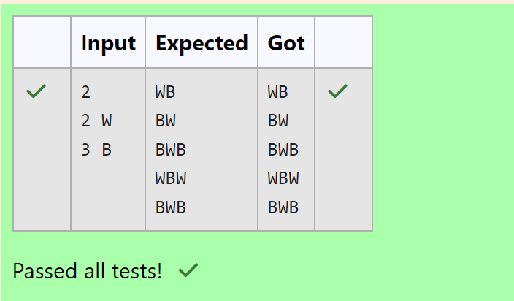

QN 3:

Decode the logic and print the Pattern that corresponds to given input.

If N = 3

then pattern will be:

10203010011012

\*\*4050809

\*\*\*\*607

If N= 4, then pattern will be:

1020304017018019020

\*\*50607014015016

\*\*\*\*809012013

Input Format

First line contains T, the number of test cases

Each test case contains a single integer N

Output

First line print Case #i where i is the test case number

In the subsequent line, print the pattern

